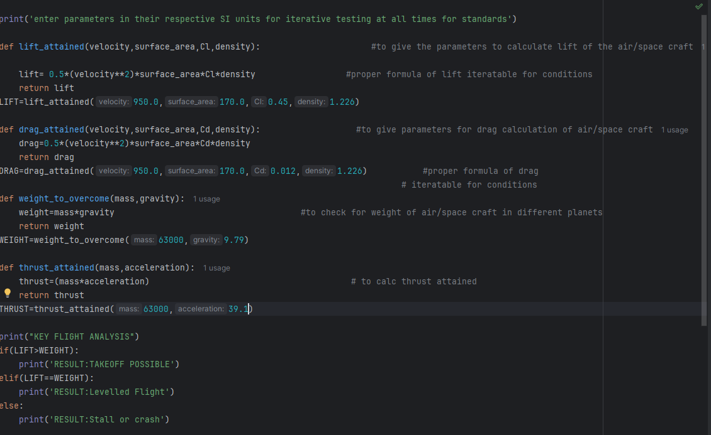
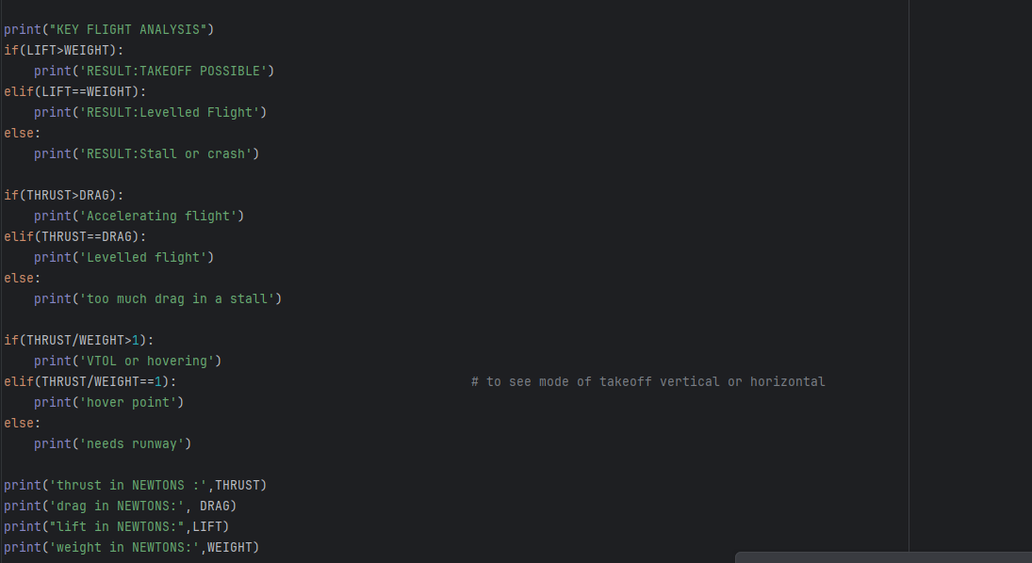

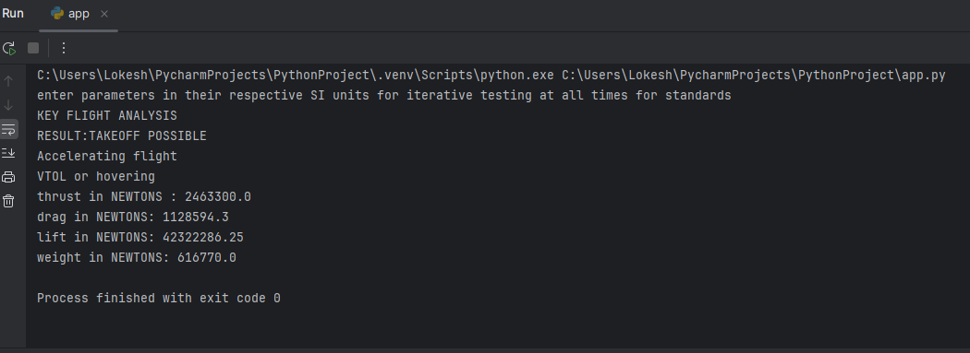

The aircraft used for my data is the SR71 “Blackbird” designed and manufactured by Lockheed Martin ( designed by Clarence” Kelly” Johnson and his team at Lockheed Martin's Skunkworks division
USED BY:
United States Air Force (1960-1990)
NASA (1991-1999)
UNIVERSAL FLIGHT FORMULAS USED IN THE PROGRAM
Lift:0.5*(velocity**2)*surface area*Cl(coefficient of lift)*density of surrounding air
Drag:0.5*(velocity**2)*surface area*Cd(coefficient of drag)*density of surrounding air
Weight=mass*gravity
Thrust=mass*acceleration
This is a universal code for any flight mission profile and any planet, not only restricted, but for the sake of simplicity, I used standard values g=9.81m/s2, mean air density=1.226kg/m3 and all units are in SI for standards

By:G.Lokesh(XI-B)

